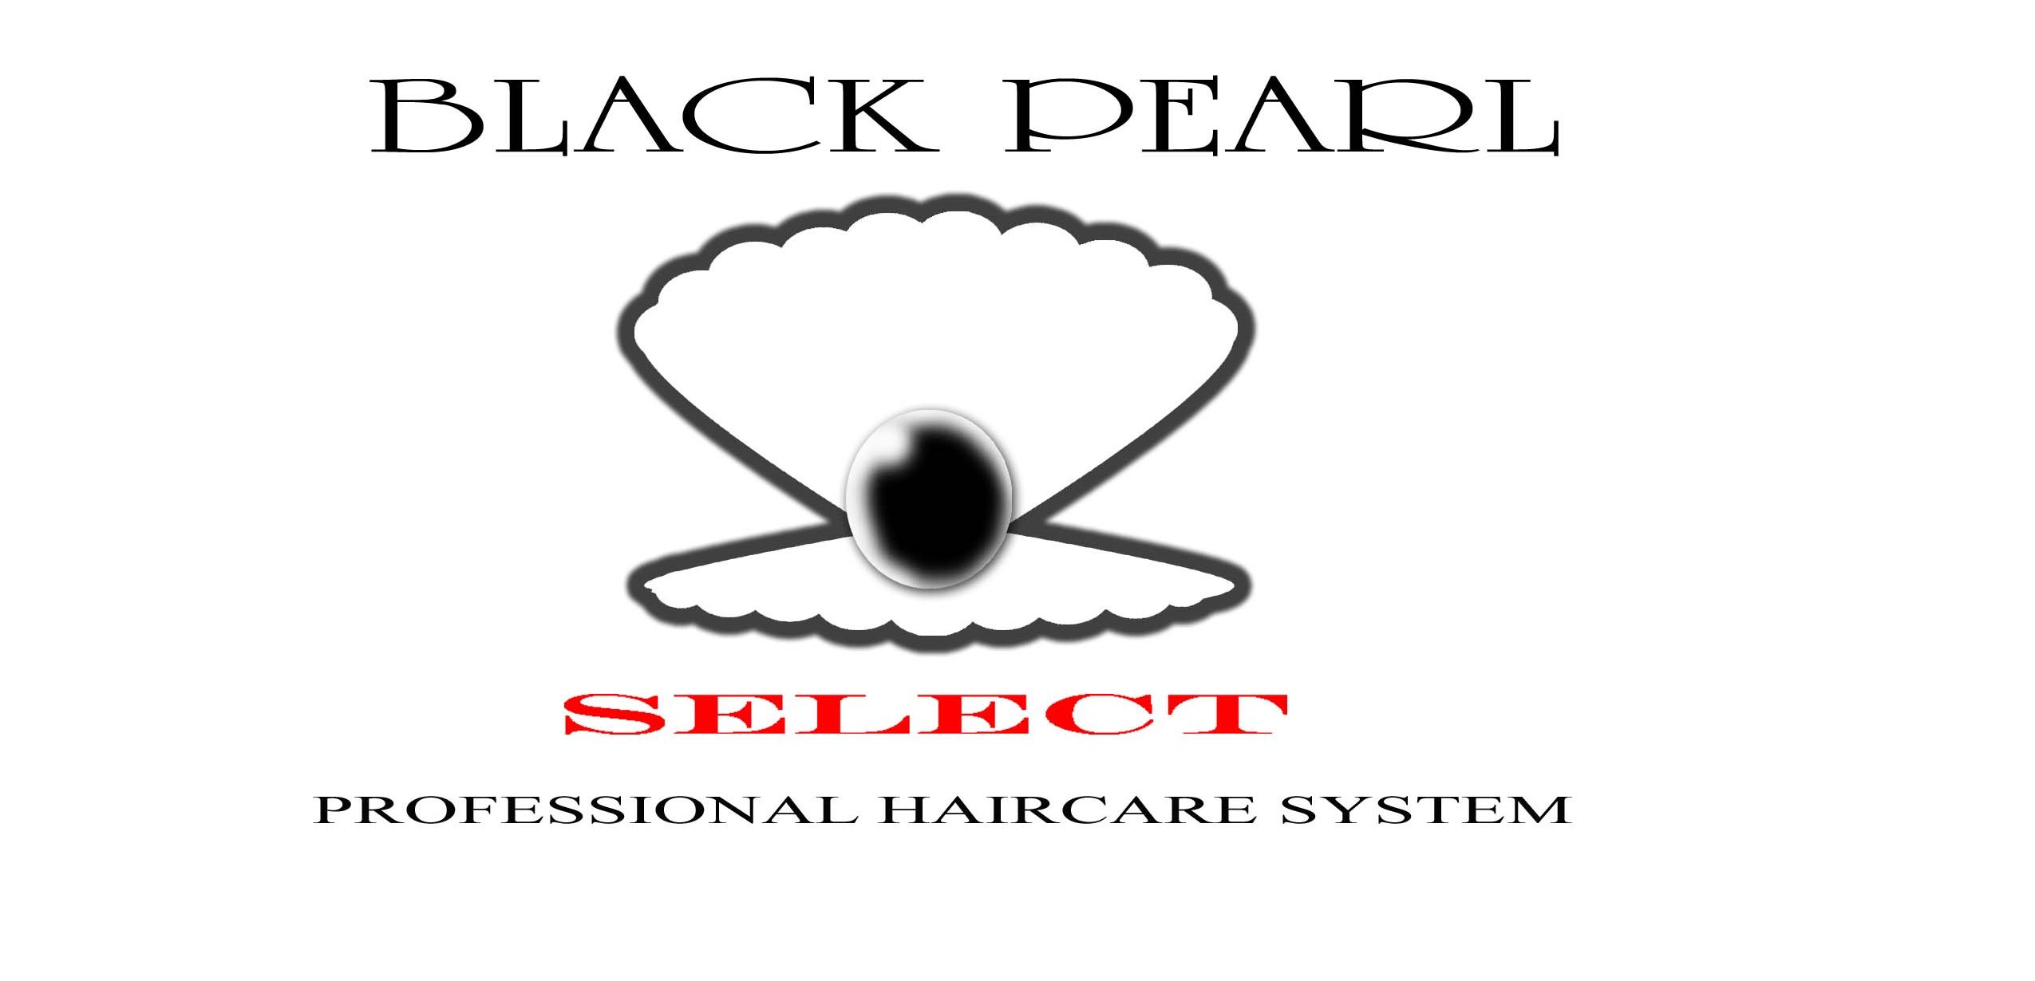
TALENT CONTEST/ARTIST ENTRY FORM

Local talent, individuals and groups, are invited to showcase their talents (comedians, singers, rappers, dancers, and poets) and compete in the 2009 Comedy Luau Talent Competition. $15 Entrance Fee per individual or group. Three microphones will be provided per group. ALL PERFORMANCES AND OUTFITS MUST BE TASTEFUL AND PRESENTABLE FOR ALL AGES.

All contestants must complete an entry form and return it by Wednesday, July 8, 2009 for the $20 entrance fee.

Music artists with professional CD's must also contact Black Pearl Select at 256.417.7609. Sale of CD is not permitted at the Comedy Luau but may be displayed during their performance. Any merchandise sold on the premises during the Comedy Luau will be confiscated by security.

3-5 minute performance time. Time permitting, an additional performance may be allowed. Check-in time for all performers is 11:00am. Contest performances begin at 12:00pm. Come dressed or get dressed on location. Consider bringing a change of clothes to enjoy the rest of the day.

Various prizes from sponsors could include trophies, gifts, studio time, and more.

EVENT DATE IS SATURDAY, JULY 11, 2009
PLEASE PRINT AND RETURN WITH VENDOR FEE

(Deadline is Wednesday, July 8, 2009 postmarked for $20 fee)
(ALL FEES ARE NON-REFUNDABLE)

Performer(s) Name _________________________________________________

Stage/Group Name__________________________________________________

Address__________________________________________________________

Phone___________________________________________________________

Email_________________________________________________________

Amount enclosed $_____________

Make Check/Money Order Payable to: Black Pearl Select – Comedy Luau 2009

Complete this portion and mail to:
Black Pearl Select Salons
2908 Meridian Street, Suite A
Huntsville, AL 35811

An email confirmation will be sent upon receipt

